Appendix 1.

Assessment of Risk Tool (ART) Flags,[23].
No | Flag | Description | Score
1 | >8 Regular Admission Meds | Admitted patients with >8 regular medications as identified via the medication reconciliation process within the previous 12 months | 10
2 | Age >65PI M | Admitted Maori and Pacific Island patients >65yrs | 10
3 | Age >75 | Admitted non-Maori and Pacific Island patients >75yrs | 10
4 | Anticoagulant | Admitted patients with one or more 'Anticoagulant' medications removed from Pyxis† during their current admission | 2
5 | Antiepileptic | Admitted patients with one or more ‘Antiepileptic’ medications removed from Pyxis† during their current admission | 2
6 | CCM CHF | Admitted patients actively enrolled or previously enrolled in the Congestive Heart Failure (CHF) Chronic Care Management (CCM) programme within the past 12 months | 4
7 | CCM COPD | Admitted patients actively enrolled or previously enrolled in the Chronic Obstructive Pulmonary Disease (COPD) Chronic Care Management (CCM) programme within the past 12 months | 4
8 | CCM CVD | Admitted patients actively enrolled or previously enrolled in the Cardiovascular Disease (CVD) Chronic Care Management (CCM) programme within the past 12 months | 4
9 | CCM Diabetes | Admitted patients actively enrolled or previously enrolled in the Diabetes Chronic Care Management (CCM) programme within the past 12 months | 4
10 | Cardiovascular | Admitted patients with >3 'Cardiovascular' medications removed from Pyxis† during their current admission | 2
11 | Diabetic Meds | Admitted patients with one or more ‘Diabetic’ medications removed from Pyxis† during their current admission | 2
12 | English Difficulty | Admitted patients identified via the medication reconciliation process with poor English comprehension difficulties OR English as a second language (within the previous 12 months) | 1
13 | Freq Presenter | Admitted patients with >4 Emergency Care presentations/inpatient admissions in the previous 12 months | 8
14 | High Risk Specialty | Admitted patients under the care of Haematology or Renal services | 6
15 | High Risk Transfer | Admitted patients transferred from Intensive Care Unit (ICU), High Dependency Unit (HDU) or Coronary Care Unit (CCU) to another ward location within the previous 48 hours | 6
16 | Mental Health | Admitted patients with a mental health history within the previous 12 months. | 8
17 | Multiple Out Patient visits | Admitted patients with >2 outpatient visits to different specialities in the previous 6 months | 8
18 | Opioid Meds | Admitted patients with >1 'Opioid' medications removed from Pyxis† during their current admission | 2
19 | Outdated Pyxis† | Admitted patients with Pyxis† medication profiles that have not been updated during the past 72 hours | 2
20 | Poor Med  Compliance | Admitted patients identified via the medication reconciliation process as having comprehension difficulties OR are poorly compliant with their medications | 1
21 | No Registered GP | Admitted patients who had their GP listed as 'Doctor Unknown' during their most recent previous admission (within the previous 12 months) | 5
22 | ReAdmit <7 days | All currently admitted patients who were discharged within the 7 days | 4
23 | ReAdmit <30 days | All currently admitted patients who were discharged within the 30 days | 2
24 | TDM Meds | Admitted patients with one of more medications requiring Therapeutic Drug Monitoring removed from Pyxis† during their current admission. | 2
25 | Prescribing for Elderly | All currently admitted patients over 80yrs AND admission source for current encounter in PIMS "Rest Home" or "Private Hospital" or "Pukekohe Hospital" or "Franklin Memorial Hospital" AND >8 regular medications on admission (as per flag #1) AND received specified high risk medications removed from Pyxis† in the past 30 days | 10
CCM is Chronic Care Management Programme, CHF is congestive heart failure, COPD is chronic obstructive pulmonary disease, CVD is cardiovascular disease, M is from Maori descent, Meds is medications, PI is from Pacific Island descent, PIMS is potentially inappropriate medications, †Pyxis MedStation™ is an automated dispensing system (from CareFusion Corporation, San Diego, CA), ReAdmit is readmission, TDM is therapeutic drug monitoring.
Adapted with permission from Am J Health-Syst Pharm, Feb 2017,[23].

Laboratory Flags (not included in validation study),[23].
No | Flag | Description | Score
1 | Poor Renal Function | Admitted patients with one of the following test results: eGFR of <30 mL/ min/1.73 m2 in past 5 days, SCr >200 mmol/L (>2.2 mg/dL) in past 5 days | 8
2 | Infection Risk (WBC) | All currently admitted patients with one of the following test results: WBC count of <3 × 109/L (<3 × 103/mm3) in past 5 days, neutrophil count of <1.5 × 109/L (<1.5 × 103/mm3) in past 5 days | 4
3 | Coagulation Risk | All currently admitted patients with one of the following test results: INR of >3.5 in past 5 days, aPTT of >100 sec in past 5 days | 10
4 | Potassium | All currently admitted patients with potassium concentration of <3 or >6 mmol/L (<3 or >6 meq/L) in past 5 days | 10
5 | Therapeutic Monitoring | All currently admitted patients with one of the following drug concentrations in past 3 days: gentamicin trough of >1.0 mg/L (>1.0 mg/mL), tobramycin trough of >1.0 mg/L (>1.0 mg/mL), amikacin trough of >1.0 mg/L (>1.0 mg/mL), vancomycin trough of >25 mg/L (>25 mg/mL), phenytoin of >80 mmol/L (>20 mg/mL), digoxin of >2.0 nmol/L (>1.5 ng/mL) | 10
6 | Clostridium Diff | All currently admitted patients with positive Clostridium difficile toxin culture in past 5 days | 2
7 | Diabetes Management (HBA1c) | All currently admitted patients with one of the following test results: HbA1c of >64 mmol/mol in past 90 days, serum glucose of >11 mmol/L (>198 mg/dL) in last 5 days | 4
8 | Myocardial Damage (Troponin I) | All currently admitted patients with two troponin values of >300 ng/mL in past 5 days | 2
9 | Deteriorating Renal Function | Rising urea or serum Creatinine concentration to >2 times baseline (baseline = mean of all values in past 5 days) | 10
10 | Hematology (Bleeding) | All currently admitted patients with drop in Hb to >25% of baseline (baseline = mean of Hb values over past 5 days) or drop in PCV to >25% of baseline (baseline = mean volume over past 5 days) or platelet count of <50 × 109/L within past 5 days | 8
11 | Warfarin Monitoring | All currently admitted patients with warfarin removed from Pyxis† during current admission and two consecutive INR values of <1.5 in past 5 days and/or aPTT of <60 sec | 4
12 | Sodium | All currently admitted patients with sodium concentration of <125 or >155 mmol/L (<125 or >155 meq/L) in past 5 days | 10
13 | Glycemic Control | All currently admitted patients with glucose concentration of <4 mmol/L (72 mg/dL) in past 5 days and received diabetic medication from Pyxis† | 10
eGFR is estimated glomerular filtration rate, WBC is white blood cell count, HBA1c is glycosylated haemoglobin, aPTT is activated partial thromboplastin time, INR is International Normalized Ratio, PCV is packed cell volume, Hb is haemoglobin, † Pyxis MedStation™ automated dispensing system (CareFusion Corporation, San Diego, CA).
Adapted with permission from Am J Health-Syst Pharm, Feb 2017.

Appendix 2.
Medication Reconciliation Form
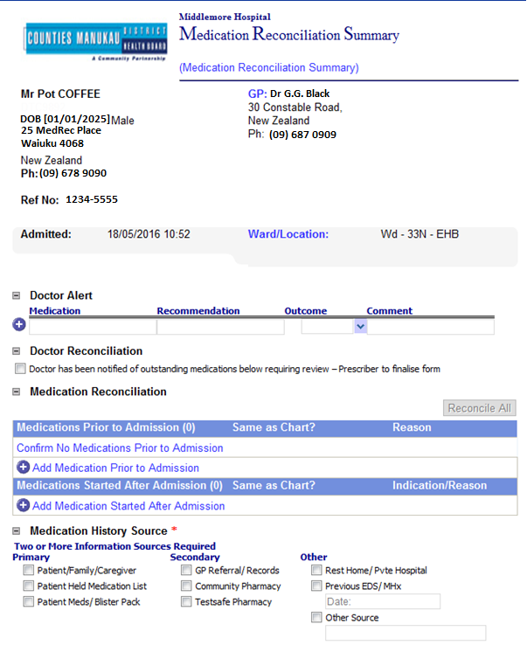

Appendix 2. continued

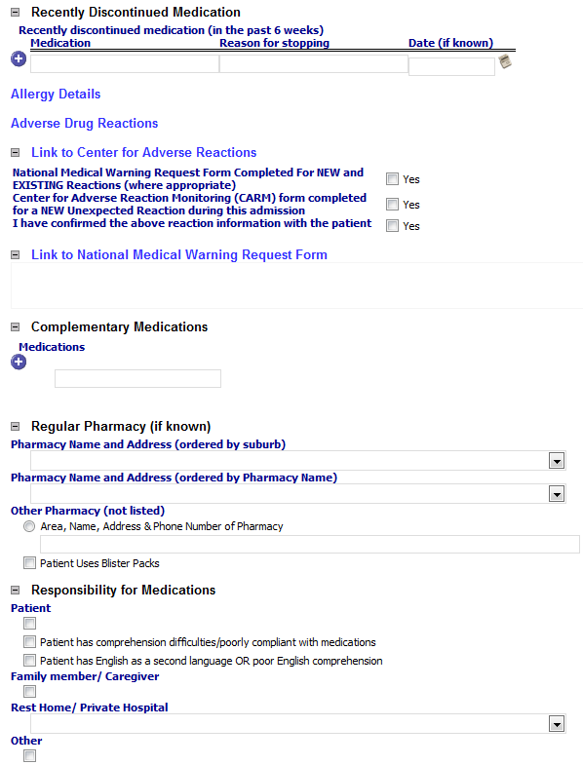

Appendix 2. continued
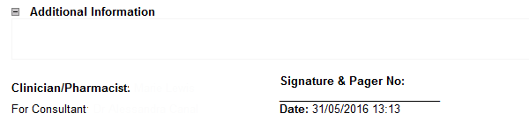

Appendix 3.

EPIFANY Grading Scale:
GRADE | DESCRIPTION
5 | An error that resulted in SERIOUS/CATASTROPHIC HARM to patient.
4 | An error that resulted in MAJOR HARM to patient. Major harm is that requiring increased hospital stay or significant morbidity.
3 | An error that resulted in MODERATE HARM to patient. Moderate harm is that requiring treatment with another drug OR cancellation/postponement of treatment.
2 | An error that resulted in MINOR HARM to patient. Minor harm is that requiring minor (non-drug) treatment or treatment change.
1 | No harm or only minor harm – not requiring “treatment”

Appendix 4. Combination of flags predictive of risk of one or more unintentional medication discrepancies.
Flags | Regression coefficient for each flag
>8 Regular Admission Medicines | 0.6
Readmit ≤30 days | 0.8

Appendix 5. Receiver Operative Characteristic (ROC) curve for combined scores of flags: >8 admission medications and readmission in 30 days, to predict ≥ 1 unintentional medication discrepancies. AUC = 0.7205

Appendix 6. Combination of flags predictive of risk of four or more unintentional medication discrepancies.
Flags | Regression coefficient for each flag
>8 Regular Admission Medicines | 0.7
Antiepileptic Medicines | 1.1
Diabetic Medicines | 0.5
English Difficulty | 0.9
Readmit ≤30 days | 0.8

Appendix 7. Receiver Operative Characteristic Curve (ROC) of the combined scores for flags:
>8 regular medications, antiepileptic medicines, diabetic medicines, English difficulty and readmission in 30 days, to predict the number of unintentional medication discrepancies ≥4. AUC = 0.8054

